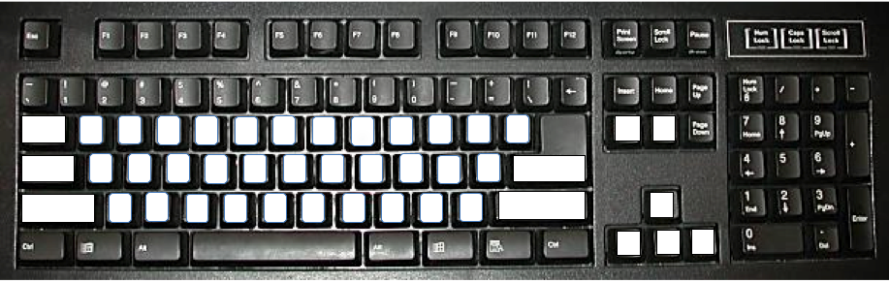
6th Grade Keyboard Practice Name______________

