Internet Safety Games
Title | Screenshot | Uniform Resource Locator (URL)
KidsCom |  | http://www.kidscom.com/games/isg/isg.html
Looney Tunes Teach the Internet |  | http://looneytunes.warnerbros.co.uk/ltti/homepage.html
Netsmartz | 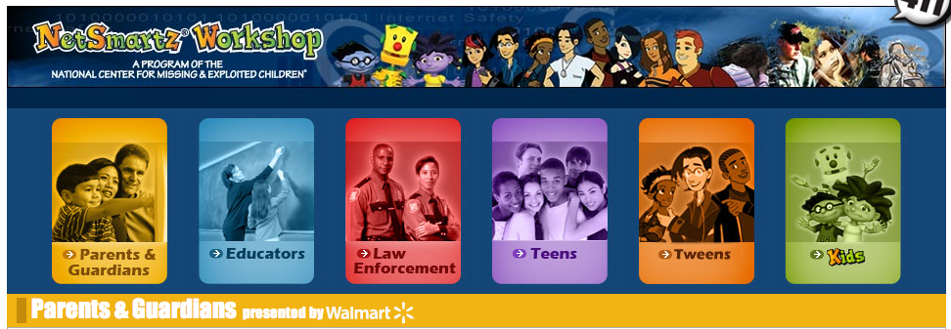 | http://www.netsmartzkids.org  http://www.nsteens.orghttp://www.netsmartz.org/Parents
Surf Swell Island Adventures in Internet Safety | 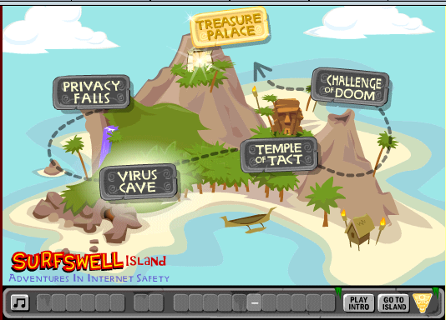 | http://home.disney.com.au/activities/surfswellisland/
Digital Passport | 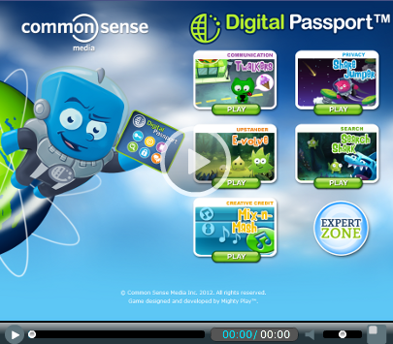 | https://www.digitalpassport.org/educator-registration/studentLogin

