Ribbons and Tabs
Electronic Worksheet

Name: |  | Period:

In the Microsoft Word program, there are several words that stretch across the top of the screen. These words are the titles of different tabs. The blue lines below point to these tabs.
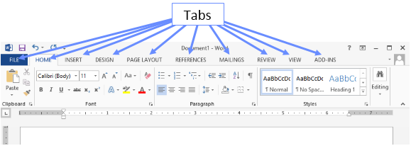

1. The tabs are highlighted with a blue line in the picture below. Starting with the File tab, list the tabs from left to right in the green boxes below (put each tab in a separate box). The File tab is put in for you. So in the second green box you would put in “Home”.
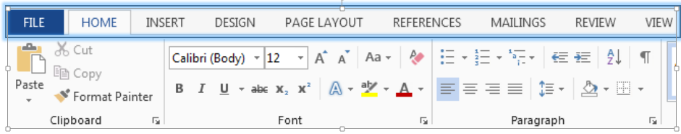
File

Continue On
(Scroll down)

When you click a tab, a unique Ribbon is displayed below that tab. Each Ribbon (much like a menu or a toolbar) holds different commands that help you complete a task. Below the Home Ribbon is highlighted with a red outline.
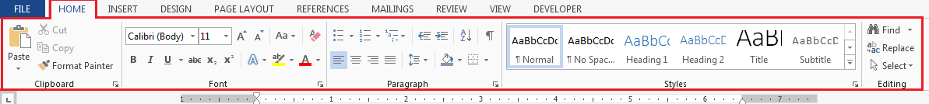

Within each tab or Ribbon is a series of groups. The green lines below point to the groups within the Home Ribbon.
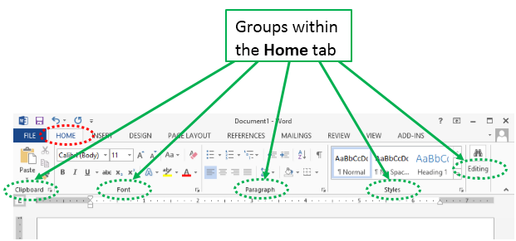

The purple lines below point to the groups within the Page Layout Ribbon.
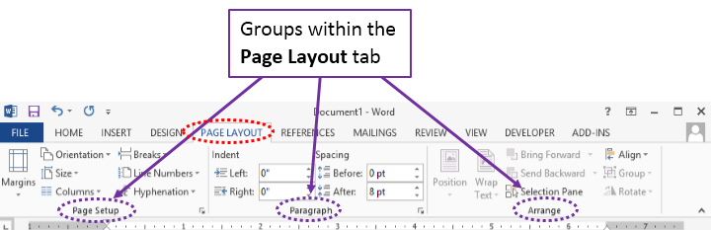

Continue On

2. Click on the Insert tab on your Word screen and it displays the Insert Ribbon. There are 10 groups on the Insert Ribbon. In the green boxes below, list the Insert Ribbon groups from left to right. The Pages group is listed in the first box for you. Fill in the rest of the groups.
Pages

Within each Group there are a set of commands. The purple boxes are highlighting the commands in the Font group.
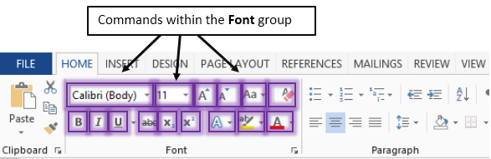

Each is command is represented by a picture or an icon. For example: The Bold command is represented by this picture or icon: . The Font Color command is represented by this icon:
Have you noticed that some of the commands are labeled and some are not? There is a quick way to find out the name of the commands that are not labeled. Simply run your mouse over the icon and an information box will pop up with the name of the command and a brief description of the command’s function. For example, when you run your mouse over the Font Color command, an information box pops up. The information box is highlighted in green (picture below).
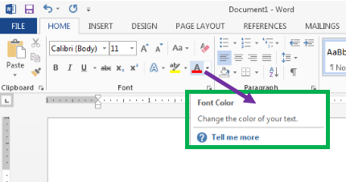
Continue On

3. Find the names of the commands listed below by running your mouse over the commands at the top of the Microsoft Word screen. Put the name of each command along with its group. Note: Some of the items are given to you. Fill in whatever is missing.
 | Ribbon/Tab | Icon | Name of Command | Group
1 | Home
2 | Home
3 | Home
4 | Home
5 | Home
6 | Home
7 | Home
8 | Home
9 | Home
10 | Home
11 | Insert
12 | Insert
13 | Insert
14 | Page Layout
15 | Page Layout
16 | Review
17 | Review
18 | View |  |  | Views
19 | View
20 | View |  |  | Zoom
21 | View
Continue On

4. Fill out the empty boxes below with the appropriate Ribbon/Tab, Command, and Group.
(You may have to search a bit for some of these)
 | Ribbon/Tab | Icon | Name of Command | Group
22
23
24
25
26
27
28
29
30

The Invisible Tool Tabs. There are some tabs that are invisible and remain invisible until you need them. These are called Tool Tabs. These tabs appear when you are using items such as shapes, pictures, and tables. When you click on these items a colored Tool Tab will appear. When clicked, this Tool Tab will bring up a new Ribbon with unique groups and commands.
For example, when you click on the Blue Rectangle below, a new (orange) tab titled “Drawing Tools” will appear. If you click on this tab a new Ribbon will appear.
Blue Rectangle
Continue On
(You’re almost done)

5. Click Blue Rectangle below and then click the “Drawing Tools” tab to find the correct Command and the Group.
Blue Rectangle
 | Ribbon/Tab | Icon | Command | Group
31 | Drawing Tools
32 | Drawing Tools
33 | Drawing Tools

Click the cute cat below and then click the “Picture Tools” tab to find the correct Command and the Group.
 | Ribbon/Tab | Icon | Command | Group
34 | Picture Tools
35 | Picture Tools

End Here:
Make sure you have #’s 1, 2, 3, 4 and 5 complete. Check your work and Save. If everything is correct, then you have completed the Ribbons and Tabs Electronic Worksheet

